**KETENTUAN TUGAS**

**CASE 1**

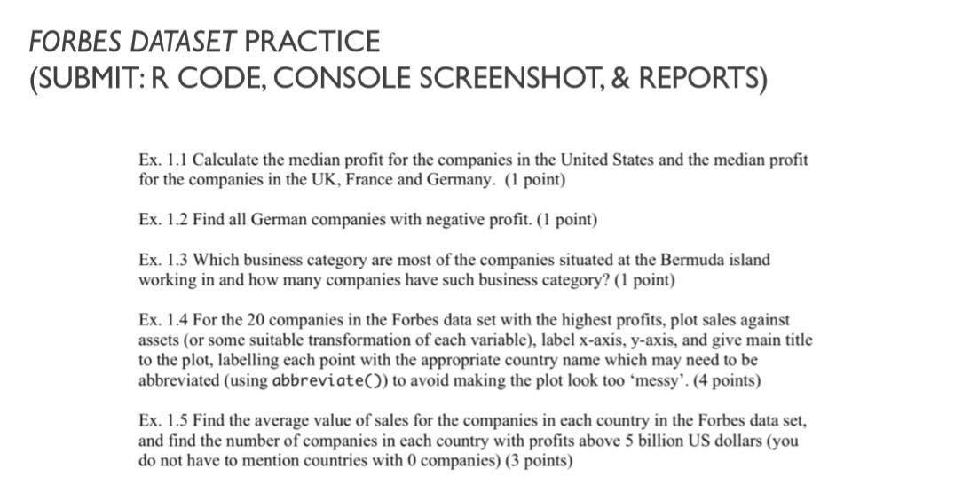

**CASE 2**

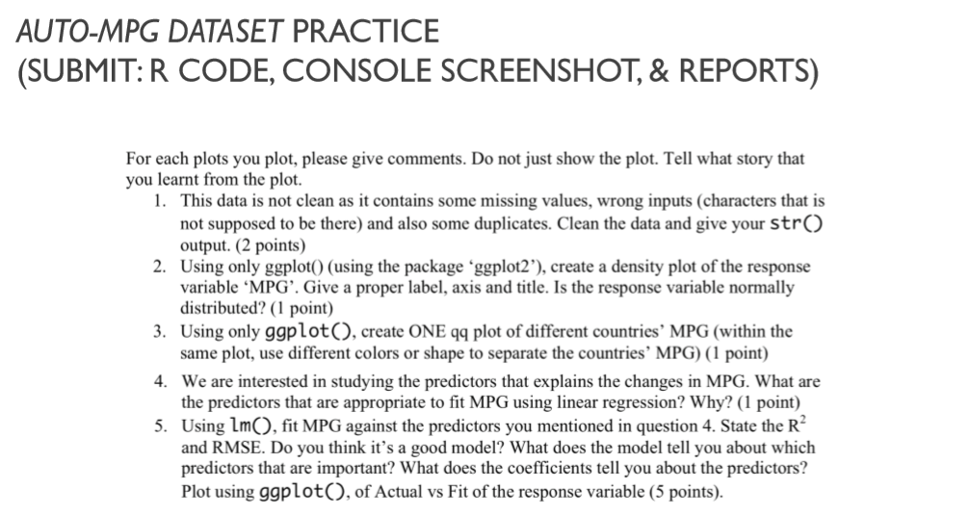

1. **Dikerjakan kelompok.**
2. **Format Penamaan: DS CASE 2 – (Nomor Kelompok XX).pdf**
3. **Deadline Pengumpulan: Jumat, 27 September 2019 23.00 WIB**
4. **Kirim ke:** [**galang23aulia@gmail.com**](mailto:galang23aulia@gmail.com)

**MR4103 SAINS DATA DAN PEMBELAJARAN MESIN – DATA PROCESSING AND VISUALIZATION**

**CASE 1: FORBES DATASET PRACTICE**

|  |  |
| --- | --- |
| **R CODE** | **CONSOLE SCREENSHOT** |
|  |  |
|  |  |
|  |  |
|  |  |
|  |  |

**JAWABAN:**

1. **XX**
2. **XX**
3. **XX**
4. **XX**
5. **XX**

**CASE 2: AUTO-MPG DATASET PRACTICE**

|  |  |
| --- | --- |
| **R CODE** | **CONSOLE SCREENSHOT** |
|  |  |
|  |  |
|  |  |
|  |  |
|  |  |

**JAWABAN:**

1. **XX**
2. **XX**
3. **XX**
4. **XX**
5. **XX**